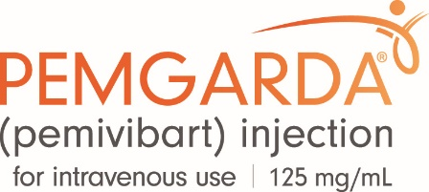
PLEASE SEE IMPORTANT INFORMATION REGARDING THE EXPIRATION DATE FOR YOUR PEMGARDA® (PEMIVIBART) PRODUCT ORDER

Please note that certain Lots of PEMGARDA may have had their expiration extended beyond the date printed on the carton and vial. Please check the FDA website for the most recent expiration dates.

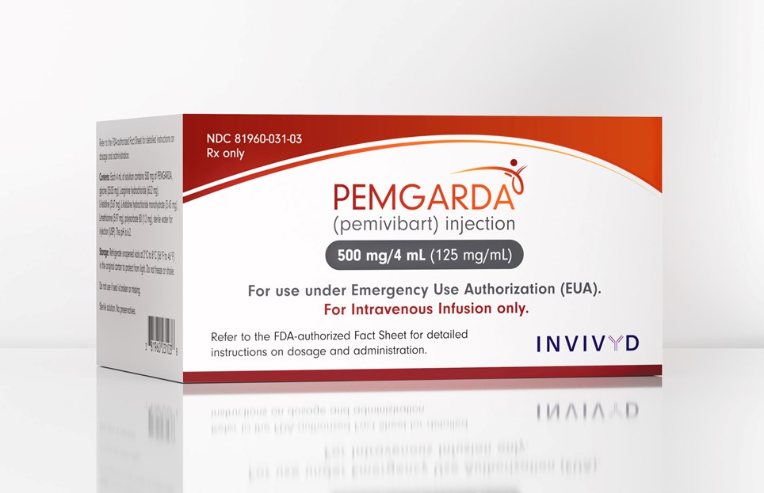 |   Scan to see the Dear HCP Letter on PEMGARDA Approved Dating by Lot

- PEMGARDA has been authorized by FDA for the emergency use described above. It is not FDA-approved for any use, including use for pre-exposure prophylaxis of COVID-19.

- PEMGARDA is authorized only for the duration of the declaration that circumstances exist justifying the authorization of the emergency use of PEMGARDA under Section 564(b)(1) of the FD&C Act, 21 U.S.C. § 360bbb 3(b)(1), unless the authorization is terminated or revoked sooner.

The FDA can allow certain medical products to be used beyond their manufacturer-labeled expiration date through issuing an Emergency Use Authorization (EUA) granted under section 564 of the FD&C Act and provided the FDA has determined that it is safe to use the product beyond its labeled expiration date. ¹
The retained product must be appropriately held in accordance with storage conditions detailed in the authorized Fact Sheet for Health Care Providers. | 
Scan to see Fact Sheet
INVIVYD RETURN POLICY
Invivyd will only accept expired, unopened product returned during the period commencing upon the product’s expiration date and ending six (6) months after the product’s expiration date as defined as the last day of the month for that Lot as shown in the Approved Extended Expiry Date in the table above. For a full list of terms and conditions and the process for requesting Invivyd product returns, please visit www.invivyd.com/returnspolicy.

¹ https://www.fda.gov/emergency-preparedness-and-response/mcm-legal-regulatory-and-policy-framework/expiration-dating-extension#COVIDtherapeutics; accessed July 14, 2025

